https://cnr.ncsu.edu/geospatial/wp-content/uploads/sites/6/2014/07/cgaBlack-300x53-1.png

Fire Hotspot Time Series Analysis:

GIS 512 – Final Project

Zach Tunstall

11/18/2020

Table of Contents

Table of Contents 2

Synopsis 3

Extended Abstract 3

Pseudocode 3

Keywords 4

Acknowledgments 4

Mapping 4

GUI 4

# Synopsis

The script tool in this project gathers tab separated data from the University of Maryland’s data base of VIIRS Fire detection locations and writes the data to a text file and converts the text files into shape files. The shapefiles are filtered and symbolized, added to a map layout, and exported as a GIF. For the time period selected by the user, the script will export several GIFS at every habitable continent on Earth. These GIFs are combined and placed in an html file.

# Extended Abstract

This project aims to visualize change detection of forest fire location on a global scale. It requires a satellite platform that covers the globe on a daily basis. The Visible Infrared Imaging Radiometer Suite (VIIRS) sensor on the Suomi-NPP satellite uses a moderate imaging spectroradiometer that provides imagery at 375m resolution. While this may be considered coarse, it is perfect for capturing the entire globe in a short time span. The University of Maryland (UM) is responsible for creating an algorithm that is based on NASA’s MODIS Fire Detection suite. UM provides data from the NOAA Satellite platform sensor VIIRS in a tab separated text file format. This data requires no log in credentials to access and is not specific to any one region. Most importantly, it is updated in “near real time” or on a daily basis. The text file format of this data makes it perfect to read and write using a python script. By taking fire detection information as a time series, we can detect when fires are forming, when they are extinguished, and we can spot areas where fires are more prevalent.

# Pseudocode

SET startdate

SET enddate

SET folder for downloads

SET Time Delta

SET Symbology Layer

SET map document file

PROC daterange

WHILE startdate <= enddate

RETURN day

startdate + Time Delta

ENDPROC

SET website url

CALL daterange

FOR day in daterange

ADD day to website url

RETURN list of website urls

ENDFOR

FOR EACH item in website url list

Write text file

ENDFOR

FOR EACH text file in folder

CALL makeXY event layer

SAVE to layerfile

CALL Symbology layer

ADD layer to map document

ENDFOR

CALL export map document to GIF

COMBINE GIFs into Animation

WRITE html file

ADD Animation to html file

# Keywords

VIIRS, Global Forest Fires, Fire Detection, GIF Animation, Cursors, Big Data

# Acknowledgments

I would like to thank the Professor and TA’s for their guidance, PythonInformer.com for help in creating GIF animations, Peter Mortensen at Stack Overflow for the assistance in generating the necessary datetime formatting and the moderators of the GIS Stack Exchange for the help in troubleshooting my geoprocessing workflows and tools.

# Mapping

The Arcpy mapping module was used to add multiple point shapefiles to several data frames that cover six continents and the world map. I then used mapping to export those data frames into GIF files.

# GUI

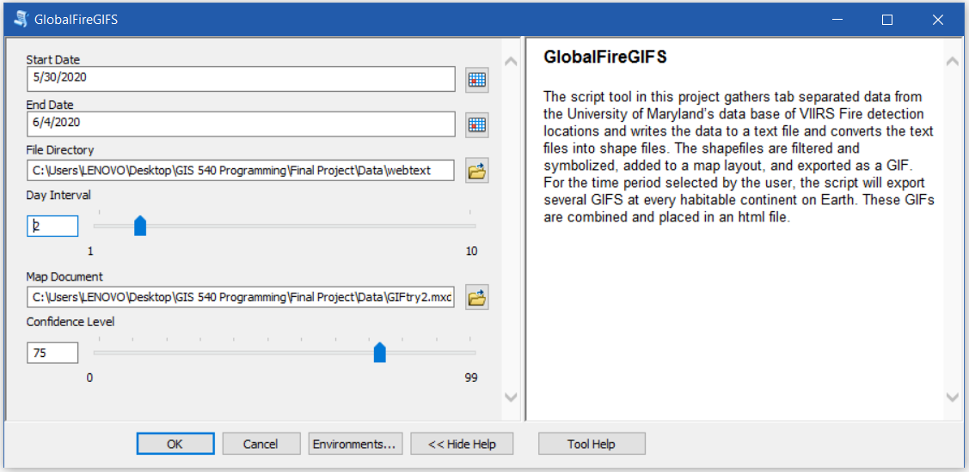

|  |  |  |
| --- | --- | --- |
| **Parameter** | **Explanation** | **Data Type** |
| Start_Date | **Dialog Reference**  Select a Date that is after Febuary 4, 2020 (Data is unavailable before this date).  There is no python reference for this parameter. | Date |
| End_Date | **Dialog Reference**  Data is typically not available within 24 hours of the current date.  There is no python reference for this parameter. | Date |
| File_Directory | There is no explanation for this parameter. | Folder |
| Day_Interval | **Dialog Reference**  Number of days to skip over.  There is no python reference for this parameter. | Long |
| Map_Document | **Dialog Reference**  Use the Default setting.  There is no python reference for this parameter. | ArcMap Document |
| Confidence_Level | **Dialog Reference**  The probability that the sensor and algorithm returned an accurate reading.  There is no python reference for this parameter. | Long |